

**Where next for the UK economy?**

Open Lecture by

Bruce V. Rauner '78 Professor of Economics, Dartmouth College, University of Stirling, IZA, CESifo, NBER and Member, Monetary Policy Committee, Bank of England

Keynes College, University of Kent 29 October 2008

[Accompanying slides](http://www.bankofengland.co.uk/archive/Documents/historicpubs/speeches/2008/speech365slides.pdf)

My thanks to Conall Mac Coille and Helen Lawton for assistance in preparing this speech and to David Bell, Carol Brown, Gary Hunt, Doug Irwin, Andrew Oswald, Andrew Wardlow and Peter Westaway for helpful discussions and suggestions

1

All speeches are available online at [www.bankofengland.co.uk/publications/Pages/speeches/default.aspx](http://www.bankofengland.co.uk/publications/Pages/speeches/default.aspx)

The Road Not Taken

“Two roads diverged in a wood, and I — I took the one less traveled by,

And that has made all the difference”

in Mountain Interval by *Robert Frost* (1874–1963)1

## INTRODUCTION

It is with great pleasure I come to the University of Kent – especially to Keynes College. I was actually invited by Professor Francis Green, who I replaced for a year at Kingston Poly while he was on sabbatical leave more than twenty years ago. I have also known Professor Alan Carruth for years. Alan has done a great deal of important work on internal and external influences on pay that has had a considerable influence on my work. I should say, though, that I haven’t given a talk at the University of Kent since 1996 even though Carruth is convinced it was only five years ago! So thanks for inviting me! My one, rather feeble, claim to a connection to the area is that I went hop-picking on a farm in Marden for two summers when I was an undergraduate in the early 1970s!

In my last speech given to the David Hume Institute in Edinburgh on 29th April 2008, I argued that more had to be done to prevent the UK entering recession and the MPC needed to be more aggressive in cutting interest rates.2 That still remains my view. Time has passed. In October the MPC voted to cut Bank rate by 50 basis points, in the midst of enormous turmoil in global financial markets.

Most people seem unaware that the monetary framework, as confirmed most recently by the Chancellor in his letter of 11th March 2008 allows for some flexibility.3 The remit says that

". the objectives of the Bank of England shall be

1 Robert Frost entered Dartmouth College in 1892 as a member of the Class of 1896. He left the College within several months, never to return as a student. He did return, however, lecturing often to classes as the Ticknor Fellow and participating in the Great Issues program. The Rauner Special Collections Library at Dartmouth holds the Robert Frost Collection. The manuscript collection contains perhaps the richest body of manuscripts and correspondence of the poet in existence.

See <http://www.dartmouth.edu/~library/rauner/manuscripts/robert_frost_guide.html>

2 <http://www.bankofengland.co.uk/publications/speeches/2008/speech346.pdf>

3 <http://www.bankofengland.co.uk/monetarypolicy/pdf/chancellorletter080311.pdf>

1. to maintain price stability
2. subject to that, to support the economic policy of Her Majesty's Government, including its objectives for growth and employment."

It also says that

"The framework takes into account that any economy at some point can suffer from external events or temporary difficulties, often beyond its control. The framework is based on the recognition that the actual inflation rate will on occasions depart from its target as a result of shocks and disturbances. Attempts to keep inflation at the inflation target in these circumstances may cause undesirable volatility in output."

The remit of the Bank of England is thus sufficiently flexible that it allows us not only to focus on the inflation target, but also to support the government's wider objectives of economic stability.

It is hard to describe in sufficient detail the scale of recent disruptions to, and effective closure of many financial markets, the failure of individual financial institutions, and interventions by governments and central banks to try to restore more ‘normal’ financial market conditions. Many financial markets remain dysfunctional and it is unclear when conditions may improve.

What is clear is that the deterioration in financial market conditions is now having an adverse effect on the broader UK economy. In the third quarter UK GDP contracted by 0.5%, the biggest contraction of UK output since the early 1990s. The unemployment rate rose sharply to 5.7%. The recently announced rise in unemployment over the last three months has been the fastest in seventeen years. Unfortunately, I expect this trend to continue, so that more than two million people will be unemployed by Christmas. Of particular concern is the big increase in the unemployment rate of those aged 18-24 which in the latest release was up 1.3pp to 13.3%, compared with an overall unemployment rate of 5.7%.

The UK is obviously especially exposed to the financial turmoil because of our dependency on the financial sector, and because the run-up in house prices and debt levels was even greater here than in the United States. My view remains that interest

rates do need to come down significantly – and quickly. If rates are not cut aggressively we do face the prospect of a relatively deep and long-lasting recession.

In my April speech I argued that the UK economy was being buffeted by two economic forces, with risks to CPI inflation on both the upside and the downside. First, the rise in CPI inflation driven by higher energy and food prices has materialised as we expected in April. This posed the risk of a wage-price spiral if inflation expectations became entrenched. I argued then that the risk of a wage-price spiral was essentially nil. And I believe subsequent developments in wages, costs and prices and measures of inflation expectations have justified that view.

On the other hand tightening credit conditions posed the risk of further falls in equity and house prices, reducing the credit worthiness of households and firms (including the banks themselves) so that financial institutions would curtail lending even further.

Certainly, the scale of the problems in financial markets has been rather worrying. As house prices have fallen, for example, loan-to-value ratios on existing mortgages have deteriorated, putting significant proportions of the population into negative equity. What has been a little harder to predict has been the reduced credit worthiness of the banks themselves. Recent efforts by the UK government to re-capitalise the banking system are welcome in this regard.

However, I believe the impact of constrained credit conditions has yet to fully feed through to the broader real economy, particularly on firms’ investment decisions. And recent events in financial markets will likely reduce lending further to both households and firms in the near term. This is a key factor underpinning my view that we need a looser monetary policy in the UK.

I have also been struck by how closely the path the UK has followed resembles that of US economy about six to nine months earlier. In part, this should not be too surprising given similar developments in US and UK housing markets, and the global nature of the financial sector. The financial difficulties that started in the US sub- prime market have now spread around the world – and governments in Austria, Denmark, France, Germany, Greece, Iceland, Ireland, and Sweden have intervened in their banking sectors. Denmark, Germany, Hungary, Ireland, Italy, Japan, Latvia,

New Zealand, and Spain, to name but a few, are already in recession. This is now a global phenomenon.

## THE RECENT RISE IN CPI INFLATION AND WAGE GROWTH

In September CPI inflation rose to 5.2%, its highest level since the Bank of England was given independent monetary policy responsibility. In 2008 the Governor, Mervyn King has written two letters to the Chancellor explaining why CPI inflation has exceeded the 2% target by more than 1 percentage point.

The main factors pushing up on CPI inflation have been external influences. In particular, higher energy and food prices have pushed up on CPI inflation and directly account for around 80% of the rise since December 2007 **[Chart 1]**. And in the August *Inflation Report* projections CPI inflation was expected to fall back towards the 2% target over the course of 2009, as the impact of past rises in energy and food prices ‘washed out’ and spare capacity emerged as output growth weakened.

A less benign view is that if expectations of future CPI inflation rose, and became entrenched, a wage-price spiral might emerge. In the 1970s persistently high rates of inflation eventually required painful policy adjustments to constrain growth and bring inflation under control. One concern has been that a similar scenario might now emerge, given the peak in CPI inflation, and that policy might have to be tighter than it otherwise would have been in order to contain inflation expectations.

I place little weight on these concerns given my experience as a labour economist who has spent his career studying wage determination.4 Since the 1970s there have been large structural changes to the labour market. Far fewer wage settlements are now explicitly ‘index-linked’ and the degree of unionisation of the labour force has diminished. Union density in the private sector is now only sixteen percent.5 **[Chart 2]** Unions have little power to raise wages, and workers care about job security. An influx of a large number of workers from Eastern Europe since 2004 has helped to

4 See, for example, David G. Blanchflower and Andrew J. Oswald, The wage curve, MIT Press, Cambridge, MA, 1994 and David G. Blanchflower and Andrew J. Oswald, 'Internal and external influences upon pay settlements: new survey evidence', British Journal of Industrial Relations, 3, pp. 363-370, 1988.

5 Source: Trade Union Membership 2007, by Sally Mercer and Richard Notley, Department for Business Enterprise and Regulatory Reform (BERR), 2008.

make the labour market more flexible and I believe these inflows will continue unabated.6 Overall labour and product market conditions, firms’ employment intentions and profitability are more likely to be taken account of in wage bargaining.

Wage settlements and final wages and salaries growth (including bonuses and wage drift) has been weak. **[Chart 3]** The AEI and the AWE measures of wage growth published by the ONS, are now also both falling back. In the latest data for August 2008 the whole economy AEI including bonuses fell to 3.2% compared with 4.3% in August 2007, and 3.8% in August 2006.7 The monthly growth rate of the AWE was 3.0% for August 2008 compared with 5.1% in August 2007 and 3.6% in August 2006.8 Wage growth is clearly now *falling*. Interestingly, workers at the manufacturing firm JCB recently voted to accept a pay cut of £50 a week to prevent the loss of 350 jobs. The GMB union said around 2,500 of its members at seven JCB plants in England and Wales had agreed to work a four-day week for the next 13 weeks to help the company weather the economic downturn.

So there is little evidence of workers resisting lower real incomes through bargaining for higher nominal wages. In part this may reflect workers being reluctant to bargain for higher wages at a time of weakening labour market conditions and greater fear of unemployment **[Chart 4].** On a monthly basis the EU asks respondents in the UK for their views on the likelihood that unemployment will rise, fall or remain the same. This is reported as a balance, which if positive implies more people think unemployment will rise. This balance has risen steadily since early 2006 and has increased very rapidly recently. The fear of unemployment has risen. I fully expect unemployment to rise further, containing any pressures on CPI from wage growth.

It is true that some inflation expectations measures have picked up over the last few months. It is plausible that these measures mainly capture perceptions of current inflation rather than expectations of CPI inflation. Those surveys that do distinguish between perceptions and expectations indicate that respondents expect CPI inflation

6 See David G. Blanchflower and Helen Lawton, 'The impact of the recent expansion of the EU

on the UK labour market', 2008, IZA Discussion paper #3695 and David G. Blanchflower and Chris Shadforth, 'Fear, unemployment and migration', Economic Journal, forthcoming.

7 Labour market statistics, October 2008, First Release, ONS, Table 15.

8 <http://www.statistics.gov.uk/downloads/theme_labour/AWE_Tables_Updated.xls>

to fall back from its current high level. For example, the Bank of England/NOP survey **[Chart 5]** indicates the share of respondents whose perceptions of current inflation are above their expectations of future inflation has risen from 26% to 45%.

Expectations obtained from market commentators and markets suggest little or no change in long term expectations, which appear to be anchored to the 2% target. Encouragingly, the YouGov Survey published on Monday of this week showed a plunge in median inflation expectations among the general public (one year ahead). Inflation expectations dropped precipitously from 4.4% in September to 2.9% in October **[Chart 6]**. Longer term expectations also fell from 3.5% in September to 2.9% in October. These are significant falls and I expect these inflation expectations measures to continue falling sharply in the months ahead.

The argument that inflation expectations may have become dislodged above the target is no longer credible. My worry is that in eighteen months or so expectations will be dislodged well below the target as inflation plummets, activity weakens and unemployment rises.

The 1970s period was also associated with a sharp pick-up in nominal GDP growth which has not been repeated this time around **[Chart 7]**. The pick-up in nominal demand growth reflected ineffectual efforts to sustain employment through traditional Keynesian macroeconomic policy stimulus, both fiscal and monetary. However, what was not appreciated at the time was the reduction in the supply potential of the economy following the large increases in real oil prices - there was a negative productivity shock. That is, in the event of an adverse supply shock, even if the monetary stance remains unchanged, ‘too much money will chase too few goods’ leading to stronger CPI inflation.

Some people have argued, that, even at their peak of close to $150 per barrel the recent rise in oil prices did not imply as severe a supply shock to the UK economy as experienced in the 1970s, given the reduced energy intensity of the economy over time **[Chart 8]**. The data in my chart show that the 2008 spike in the real oil price is at least as high as in the 1970s. However, the importance of oil as an input to the production process has fallen over time, in part due to the relatively strong growth of the services sector over manufacturing. That is, the ratio of real oil consumption to

GDP has fallen. So the impact of the current oil price shock on the UK economy should be less severe than in the 1970s.

A number of economists have argued that oil spikes have significant macroeconomic effects. James Hamilton, for example, has pointed out that “nine out of ten of the US postwar recessions since WWII were preceded by a spike up in the price of oil".9 The literature suggests that it does take considerable time for the adverse effects of an oil price shock to feed through to the real economy. One possibility is that the negative effects of the oil shock have been under-estimated and the delayed impacts will be almost as marked as in previous oil shocks. The worry then is that this prior rise in oil, commodity and food prices would lead to additional unemployment down the road. There is evidence that the repercussions of oil shocks take years to dissipate.

It is to be welcomed, of course, that oil prices have now fallen closer to $60 per barrel, which would lessen this effect. That is good news. Similarly, global commodity, food, raw materials and metal prices have now begun to decline sharply coincident with slowing world demand. These price falls will put downward pressure on CPI both through their direct impact within the consumption basket and their indirect impact on firms’ costs. So to the extent that oil, food and energy prices pushed CPI inflation above target, as explained by the MPC’s recent letters to the Chancellor, they are likely to push CPI inflation below the 2.0% target in the next year.

I do not believe that inflation expectations are somehow stuck at some high level and that is why monetary policy cannot be loosened. Commodity, food and energy prices are falling, as are house prices and measures of inflation expectations. There is little evidence from the real world that inflation expectations, whether measured from what individuals or commentators say, are stuck above the 2% target. I think the British people are smart enough to have actually noticed that inflation is coming down fast.

9 Hamilton, James D., 'Oil and the Macroeconomy', in the New Palgrave Dictionary of Economics, Second Edition, 2008.

## THE IMPACT OF THE CREDIT CRUNCH ON THE REAL ECONOMY

It is most likely the current ‘energy price shock’ will be less damaging than those faced in the 1970s. In contrast, monetary policy makers are now faced with an international financial problem that is unusually severe. It is even possible that this event may turn out to be more significant than the 1929 crash which principally involved bank failures in the United States. The current difficulties in financial markets are more global in nature and more comparable to what happened in the First World War, when stock exchanges in several countries were closed for extended periods.10 But it remains to be seen whether such gloom is justified, and we must remember that economies typically bounce back, although there are tough times ahead. The banks have been recapitalized and the government is acting to stimulate the economy. The government’s focus on helping small firms, who are especially vulnerable, is also welcome.

I will not attempt to give you a ‘blow by blow’ account of the failings of individual financial institutions and corresponding public policy responses. Similarly, it is difficult to describe what has happened to the economy in terms of summary statistics. For example, although the high spread of LIBOR (a measure of the rate at which banks had lent to each other) over the Bank of England policy rate reflects the credit crunch**,** it does not fully capture the effective closure of many money markets [**Chart 9]**. That is, many banks have recently been unable to acquire term funding even at the LIBOR rate.

Rather I will try to explain that in many ways the impact of the credit crunch on the real economy has been predictable, but has not yet fully worked through. At the same time I will briefly touch upon the unforeseen impact of the turmoil in financial markets, that is, the tremendous impact on the credit worthiness of the lending institutions themselves.

The impact of tightening credit conditions can be described as a vicious circle in which higher interest rates push down on equity and house prices, eroding the amount of collateral available for firms’ and households to secure their borrowing against **[Chart 10]**. This collateral effect makes firms and households riskier prospective

10 See Lombard Street in War and Reconstruction by Benjamin H. Higgins published in 1949 by NBER <http://www.nber.org/books/higg49-1>and The Pity of War by Niall Ferguson, Penguin Press, 1998

borrowers for banks and lending institutions, so that they tighten credit availability further.

Over the last year mortgage lending has tightened considerably, both in price and non- price terms. The overall level of mortgage lending has fallen sharply, contributing to falling UK house prices**.** As house prices fell households became riskier prospective borrowers. That is, in the event of a mortgage default, the probability of banks taking on negative equity from a household, and the associated losses, had increased. The Bank of England’s September *Credit Conditions Survey* indicated lenders expected to continue tightening secured lending to households, and that falling house prices were a key consideration in this view.

A range of indicators suggest credit availability to UK non-financial corporations (PNFCs) has also tightened. Corporate bond spreads have risen sharply and the *Credit Conditions Survey* indicates lenders expect to continue tightening credit availability to the corporate sector. However, the effective rate on lending to the corporate sector has fallen over the past year – indicating that UK firms have yet to face the full impact of the credit crunch.

This could be because UK firms have been drawing on committed lines of credit, rather than funding investment on less favourable terms. Consistent with this hypothesis, the UK bank funding gap (the difference between deposits and liabilities) with the corporate sector has not yet fallen back **[Chart 11].** In contrast, the bank funding gap with households has fallen sharply over the past year. That is, banks have scaled back on their net lending to households but not to the corporate sector. Digging a little deeper shows that banks have had to finance this funding gap by sales of their foreign assets **[Chart 12].**

Clearly this situation is unsustainable. Once committed lines of credit are exhausted, investment is likely to fall back sharply as firms are fully exposed to tighter credit conditions and rein in spending plans. Indeed, the *Credit Conditions Survey* indicates that reduced capital investment plans by PNFCs have already depressed credit demand and are expected to do so further in the future. The danger then is that firms will close and redundancies will rise. Credit constraints are particularly important for

small firms and their ability to survive and flourish and even to be born in the first place.11 Credit constraints are also likely to impact negatively on job creation.

The October 2008 *CBI Industrial Trends Survey* indicates that the proportion of firms citing credit finance issues as a constraint on output rose from 3% to 9% - the highest level since the mid- 1970s. Even more alarming is that the proportion of firms who cited access to credit as a constraint on investment rose from 4% (in the July Survey) to 16%, the highest recorded level since the series began in 1979.

So a further retrenchment of consumer and investment spending is to be expected. We start from a situation in which the UK economy is already in a weak position. The historically low household savings ratio and further falls in equity and house prices will push down on consumer spending. Retail sales, distributive trade figures and vehicle purchases indicate consumer spending slowed sharply in Q3, as I had feared. As inflation falls back in 2009 this should provide some stimulus to consumer spending by pushing up on real income growth. But overall I judge the risks to consumer spending to lie to the downside.

One sector that is particularly exposed is construction where orders for private commercial and residential construction have fallen off very sharply. Until commercial property and house prices stabilise construction is likely to continue detracting from growth.

Given the depreciation of sterling the UK might have been expected to benefit from growth in its exports. However, the IMF has revised down its forecast for world GDP growth to 3.0% in 2009, with growth in the ‘advanced economies’ expected to equal 1.5% in 2008 and just 0.5% in 2009. So demand for exports is likely to be weak. The October 2008 CBI *Industrial Trends Survey* indicates that the decline in export orders in the latest quarter is the strongest since October 2003, and that employment in the manufacturing sector is likely to contract sharply.

11 See David G. Blanchflower and Andrew J. Oswald, 'What makes an entrepreneur?', Journal of Labor Economics, January, 16(1) pp. 26-60, 1998: David G. Blanchflower, Phillip Levine and David Zimmerman, ‘Discrimination in the market for small business credit’, Review of Economics and Statistics, November 2003, 85(4), pp. 930-943 and David G. Blanchflower, 'Minority self-employment in the United States and the impact of affirmative action programs', forthcoming in Annals of Finance, January, 2009.

There is now evidence from the Baltic Dry Index that world demand is slowing fast. This useful and sometimes overlooked index measures the price of shipping dry goods such as grain, iron ore and coal. The index has fallen by 91% since its peak in May **[Charts 13 and 14].** Trade credit is unavailable for financing freight which has traditionally been written at the LIBOR. The Baltic Dry has fallen by an average of over nearly seven percent a day over the last two weeks. The implications are then that the reduced cost of transportation will feed through to lower prices. Indeed, the price of iron ore, coal and other commodities such as aluminium, copper, steel and cotton as well as the prices of foodstuffs such as sugar, corn, wheat, cattle and soybeans have all been falling quite rapidly recently.

One risk to the outlook for UK is that the sterling depreciation will push up on UK import prices. However, much of this effect has probably passed through already. And falling energy and commodity prices will push down on UK import prices. Similarly, lower shipping costs and slower world demand should depress global trade prices, which had picked up over the recent past. Also, with domestic demand expected to slow sharply any increase in UK import prices is likely to be absorbed into firms’ profit margins rather than be passed through to their final consumer prices.12

Together this evidence suggests the impact of the credit crunch on firms’ capital spending is only just beginning to be felt, and will strengthen in the future, at the same time that CPI inflation will fall back sharply. These negative demand effects are in themselves not particularly surprising, but were broadly predictable.

## THE PROBLEMS IN FINANCIAL MARKETS

What has been difficult to predict about the current episode of financial turmoil has been the impact on the perceived credit worthiness of the lending institutions themselves. Indeed, the share prices of banks have fallen considerably, by around 65% on average, and to a far greater extent than either the FTSE 100 or measures of average UK house prices **[Chart 15].** And as their share prices have fallen the banks have found themselves increasingly capital constrained. So the most risky prospective borrowers have been the lending institutions themselves.

12 See MacCallan C., Millard, S., Parker M. (2008) ‘The Cyclicality of Mark-Ups and Profit Margins for the United Kingdom: Some new evidence’, Bank of England Working Paper No. 351.

This pressure on banks’ capital positions has been amplified by the opaque and complex nature of a range of financial market instruments such as securitised assets and their derivatives. In short, the complexity of these assets has meant it has been extremely difficult to tell which, and by how much, banks are exposed to adverse housing market developments, particularly in the US. This has led to large write downs on the value of mortgage backed securities and large profit losses for the banks that hold them. Indeed, the markets for these asset classes have largely dried up as the appetite for risk has fallen back sharply.

The dependence on short-term funding, often through sales of securitised assets, has left some banks exposed to tightening credit conditions. We have arrived at the point where money markets are dysfunctional, with banks unwilling to lend to each other at anything other than short-term maturities, as they have hoarded liquidity and perceived large default risks on behalf of other financial institutions.

Recent efforts to re-capitalise the banks and restore ‘normal’ lending conditions are welcome. Despite these measures spreads on credit default swaps for UK banks have halved but remain elevated. Going forward, conditions in money markets may improve gradually. But any improvement is likely to be passed on to households and the corporate sector slowly. Rather, credit availability is more likely to be curtailed further in the near future.

The broad ranging interventions by many governments and central banks in financial markets pose many difficult questions about the role of government in the economy, the appropriate level of government regulation of financial markets, and the interaction between policies to promote monetary and financial stability.

My role on the MPC is to help to set monetary policy so as to meet the 2% CPI inflation target as set out by the Treasury in its remit to the Bank of England. Hence, I will not address these questions in any great detail. However, I do welcome efforts by the international Financial Stability Forum (in which the Bank of England has taken an active role) in considering new regulatory structures to improve the efficiency of financial markets. Measures that increase the transparency in markets for financial assets of a ‘toxic’, ‘radioactive’ or otherwise hazardous nature can only

increase the efficiency and stability of these financial markets. And I believe regulation can play a positive role in this regard.

The last decade has often been described as the period of the ‘great moderation’ or ‘great stability’. And this stability had often been attributed to improved monetary policy across many economies. However, this stability has ended with significant problems in the global financial system. My suggestion is that we should be wary of bouts of excessive optimism and of excessive pessimism. A useful thing to bear in mind – it was forgotten in the upswing – is that housing and stock markets tend to be mean-reverting. They go back to the usual trend.

I believe central bankers need to think carefully about what additional instruments are required to address pro-cyclical behaviour by banks. The Financial Stability Forum has considered the use of “macro prudential instruments”, such as reserve requirements that fluctuate with the economic cycle, to tackle pro-cyclical behaviour in financial markets and help prevent unsustainable asset price and credit booms13.

In the future we need to realise that the counterpart to ‘irrational exuberance’ by bankers on the upside may be undue restraint in lending to households and firms as the economy enters recession. There is now a concern of a downward spiral in the UK of falling asset prices and tightening credit conditions.

In summary, the events in financial markets are likely to amplify the impact of tightening credit on the broader UK economy and CPI inflation. Sadly, credit availability for individual UK households and firms is likely to be constrained, specifically because of the poor decisions, performance and credit worthiness of the UK’s lending institutions themselves. Hence, we need to cut interest rates not to protect the banks, but to protect the public from the banks.

## IS THIS IS A SURPRISE?

Should the deteriorating economic outlook have been a surprise? It is often difficult to map survey evidence into out-turns of economic activity when growth is close to, or around trend. However, the correlation between surveys and real activity is

13 See ‘Rebuilding Confidence in the Financial System, Speech by Sir John Gieve at the British Banking Associations, 12th Annual Supervision Conference, October 28nd, 2008.

particularly marked when the economy is in recession. And since the summer of 2007 a very broad range of forward looking surveys of UK economic activity have shown a marked downturn.

Over the last year or so I have been watching these surveys. The surveys that were most worrying were those capturing consumer and business confidence and those relating to the labour market. The *GFK Consumer Confidence Surveys* started to deteriorate sharply from early 2008 and REC demand for permanent staff balance fell strongly throughout the year **[Chart 16].** The CIPS Manufacturing and Services balances, which give a strong reading of growth in those sectors, both passed through the 50 - no change level in Q2 2008 **[Chart 17].** So it should been apparent for some time that output would most likely contract in the third quarter. Economists seem to have placed insufficient weight on these surveys.

I have also been struck by the surveys conducted by the Confederation of British Industry (CBI) and the British Chambers of Commerce (BCC). The *CBI Industrial Trends Survey* is especially gloomy; optimism of the business situation has been falling steadily throughout 2008 [**Table 1]**. A similar story can be seen for the volume of orders and employment. The BCC surveys are quarterly samples of 5000 firms with separate results for manufacturing [**Table 2]** and services [**Table 3]**. The *BCC Quarterly Surveys* showed activity rapidly decelerating from around Q1 2008 onwards in both the manufacturing and services sectors. Respondents to these surveys indicated an ever gloomier picture for firms’ employment intentions, business confidence, investment, sales and orders.

I argued in my speech in April that the UK was following closely behind the US experience and so it has turned out. I identified four stages that both countries have followed. Since that time the UK followed the US into stage four which indicates recession. The dates are approximate.

## Phase 1 (August 2007-October 2007).

House prices start to slow.

## Phase 2 (November 2007-January 2008).

Consumer confidence and qualitative labour market surveys slow sharply.

## Phase 3 (February 2008-August 2008).

House prices falls start to accelerate, quantitative labour market begins to slow, wage growth weakens, and real consumption starts to fall.

## Phase 4 (September 2008-) Recession.

Sharp drops in consumer spending, retail sales and real activity and big increases in unemployment.

As recently as August, the MPC’s *Inflation Report* projections indicated that in the MPC’s central view was that *‘output would be broadly flat over the next year or so’* and ‘*employment falls a little*’ **[Chart 18].** Output growth was expected to pick-up gradually "*as the restraining effect of higher energy prices on demand and output dissipates, credit conditions ease and the lower level of sterling continues to support net trade*".14 This was an optimistic view.

Clearly output is now beginning to contract, but I think this likelihood was apparent in August. At the September MPC meeting ‘*most members judged that maintaining Bank Rate at 5% this month was necessary if inflation was to be brought back to the target in the medium term*’. The minutes of the September meeting also indicate that ‘*a case could be made for an increase in Bank rate’*. This was not my view. At that meeting I was alone in voting for an immediate cut in Bank Rate by 50bps. At its October meeting the MPC voted unanimously to cut interest rates by 50bps to 4.5%.

With hindsight, monetary policy has not been sufficiently forward looking. Changes in monetary policy only affect the real economy with a substantial lag. Hence, monetary policy makers must take a medium-term view concerning the forces hitting the UK economy and set policy accordingly. It is not sufficient to consider the data month by month until it emerges that the UK is in recession. I believe the trend has been apparent for some time. The synchronized downturn in so many business surveys should have led us to realise sooner that the UK economy was entering a recession.

## WHAT HAVE ECONOMISTS HAD TO SAY?

What was the role of economists in all of this? In the US, where I live, economists such as Bob Shiller, Nouriel Roubini, Marty Feldstein and Larry Summers, among

14 August 2008 Inflation Report, Bank of England, p7.

others, were warning of the problems that were approaching. But is hard to think of many commentators who anticipated the difficulties the UK economy now faces, despite the similarities with the US experience.

Academic economists seem to have been too busy publishing theoretical papers rather than looking at data and solving some of the greatest economic policy issues of our age. Difficulties arise when a subject emphasises theory over empirics. Theory is fine but we need to *test* it against data from the real world to see if it is actually true rather than just elegant.

In the UK economics has traditionally tended to emphasize the importance of theory, downplaying the role of observation. Larry Summers, said it well in relation to macro- economics.

*"Good empirical evidence tells its story regardless of the precise way in which it is analyzed. In large part it is its simplicity that makes it persuasive. Physicists do not compete to find more elaborate ways to observe falling apples. Instead they have made progress because theory has sought inspiration from a wide range of empirical phenomena. Macroeconomics could progress in the same way. But progress is unlikely as long as macroeconomists require the armor of a stochastic pseudo-world before doing battle with evidence from the real one.*"15

The key economic policy issue over the last decade has been the unsustainable rise in asset and equity prices and associated credit boom. But too often this boom has been dismissed with the mantra that ‘*financial markets price assets efficiently*’. It seems less obvious than it did even a year ago that monetary policy designed around the monetary framework of the Bundesbank in the 1970s is that appropriate for an entirely different set of circumstances in the 2000s.

I am struck by Paul De Grauwe's comments in the Financial Times

*“There is a danger that the macro-economic models now in use in central banks operate like a Maginot line. They have been constructed in the past as part of the war against inflation. The central banks are prepared to fight the last war. But are they prepared to fight the new one against financial upheavals and recession? The macroeconomic models they have today certainly do not provide them with the right tools to be successful. They will have to use other intellectual constructs to succeed.”* Financial Times, July 22nd, 2008.

15 Summers, L. H. (1991), 'The scientific illusion in empirical macroeconomics’, Scandinavian Journal of Economics, 93(2), pp. 129–48.

The workhouse models for monetary policy analysis by central banks over the last decade are largely based on the new-Keynesian Phillips curve literature. This class of real business cycle models incorporate some nominal rigidities, but are actually more in the tradition of Friedman, stressing the importance of inflation expectations. However, there is little role for financial intermediation, money supply growth, asset prices and changes in the structure of wage setting which inevitably limits their usefulness. These models have been a poor tool for monetary policy makers.

Robert Skidelsky in a recent article in the Washington Post argues that

*"But what is in even shorter supply than credit is an economic theory to explain why this financial tsunami occurred, and what its consequences might be. Over the past 30 years, economists have devoted their intellectual energy to proving that such disasters cannot happen. The market system accurately prices all trades at each moment in time. Greed, ignorance, euphoria, panic, herd behaviour, predation, financial skulduggery and politics -- the forces that drive boom-bust cycles -- only exist off the balance sheet of their models. So mainstream theory has no explanation of why things have gone so horribly wrong*". Washington Post, Tuesday, October 14th, 2008

Lord Skidelsky goes on to suggest that to understand how markets can generate their own hurricanes we need to return to John Maynard Keynes. Is Skidelsky right? What is the actual evidence? Was the financial crisis predictable? It is perfectly possible that as economists we had insufficient understanding of the importance of herd behaviour in all of this, in housing and money markets, and that economics is too short of work on such phenomena. Above all, was there something we economists could reasonably be expected to have said and then done well before the crash? Why didn’t we pay more attention to tail risks? The events of the last twelve months represent a challenge to economists. Does mainstream theory have an adequate explanation of why things have gone so badly wrong? It is not clear it does. It may well be time for a rethink.

## WHAT DOES THIS MEAN FOR MONETARY POLICY?

In his recent speech in Leeds on October 21st the Governor of the Bank of England Mervyn King said it was ‘likely that the UK economy is entering a recession’. I agree that we are in a recession. The big questions are for how long will it last and how deep will it cut?

It seems to me that the risks from heightened inflation expectations should have been treated as benign, given the structure of the UK labour market and the slowdown in activity that has been apparent in surveys of economic activity for some time. The continued weakness of wage growth confirms this view and coupled with rising unemployment and falling inflation expectations measures, it seems reasonable to assume that this risk has now passed. It is clear to me where the balance lies between the hypothetical risk of entrenched inflation expectations versus the real risk of higher unemployment and weakening economic activity that is now materialising.

I am concerned about the detrimental effect of recent events in financial markets on the UK economy. The contraction of UK GDP in the third quarter occurred mainly before the events in financial markets in September and October. And the impact of tighter credit conditions has yet to be fully felt by firms and households.

Nevertheless, it is a mistake to be overly gloomy or to focus excessively on the near- term. The herd behaviour that took us up can also take us down, and that would be unfortunate. Modern economies have proved themselves resilient to downward shocks and in the long run there is much about which we should be optimistic. Britain’s economy will, eventually, recover.

However, UK output will continue to contract in 2008 and through 2009. At the same time CPI inflation is likely to fall back sharply over the next year or so to well below the 2% target. My concern is that inflation will be below 1% - and maybe even negative – and the MPC will then be writing letters on the low side, which is not a healthy prospect. In summary, I believe interest rates should be reduced.

I do think that the appropriate institutional structure is in place to deal with the problems the UK economy now faces. The Treasury, the FSA and the Bank of England are working together to find solutions. The objective of the MPC is to bring things back to normal.

I believe inflationary pressure is clearly dissipating so that monetary policy can be loosened, to ensure CPI inflation returns to target in the medium term and growth in the economy recovers. Therefore the message I would like to leave with you is a

positive one. In the medium term our economy will recover and prosperity will return.

## Table 1: CBI Industrial Trends Survey – Business prospects and plans

|  |  |  |  |  |
| --- | --- | --- | --- | --- |
| **Business prospects and plans** |  | 2008 | |  |
|  |  |  |  |
| Optimism re business situation | -60 | -40 | -23 | -18 |
| Optimism export prospects 1 year ahead | -35 | -16 | -8 | -5 |
| Volume of total new orders | -36 | -12 | 2 | 4 |
| Volume of domestic orders | -42 | -21 | -9 | 3 |
| Volume of export orders | -21 | -8 | 5 | 0 |
| Numbers employed | -33 | -27 | -17 | -19 |
| Average domestic prices | 10 | 34 | 25 | 21 |
| Average export prices | 14 | 28 | 15 | 9 |

Source: CBI Industrial Trends Survey, 21st October 2008

## Table 2: BCC Quarterly Economic Survey – Manufacturing

|  |  |  |  |  |
| --- | --- | --- | --- | --- |
| **MANUFACTURING\*** | 2008 Q3 | 2008 Q2 | 2008 Q1 | 2007 Q4 |
| Sales - Home sales | -22 | -2 | 12 | 19 |
| Home orders | -30 | -8 | 9 | 17 |
| Export sales | -1 | 18 | 13 | 10 |
| Export orders | -10 | 13 | 12 | 12 |
| Employment last 3 months | -3 | 8 | 5 | 5 |
| Employment next 3 months | -9 | -2 | 9 | 7 |
| Cashflow | -17 | -16 | -6 | 7 |
| Investment - plant & machinery | -6 | 0 | 8 | 10 |
| Investment - training | -1 | 5 | 22 | 17 |
| Confidence - turnover | 1 | 24 | 39 | 43 |
| Confidence - profitability | -17 | -4 | 13 | 27 |
| Full capacity | 38 | 40 | 45 | 39 |
| Prices | 43 | 53 | 47 | 39 |

Source: BCC Quarterly Economic Survey

*All companies, unweighted. All figures expressed as a percentage balance.

## Table 3: BCC Quarterly Economic Survey – Services

|  |  |  |  |  |
| --- | --- | --- | --- | --- |
| **SERVICES\*** | 2008 Q3 | 2008 Q2 | 2008 Q1 | 2007 Q4 |
| Sales - Home sales | -7 | -1 | 15 | 24 |
| Home orders | -11 | -8 | 8 | 18 |
| Export sales | 8 | 1 | 3 | 12 |
| Export orders | 0 | -1 | -3 | 9 |
| Employment last 3 months | 4 | 4 | 13 | 20 |
| Employment next 3 months | 4 | 7 | 19 | 23 |
| Cashflow | -13 | -11 | 2 | 8 |
| Investment - plant & machinery | -5 | -1 | 5 | 12 |
| Investment - training | 6 | 10 | 20 | 22 |
| Confidence - turnover | 13 | 19 | 37 | 49 |
| Confidence - profitability | 0 | 2 | 17 | 26 |
| Full capacity | 36 | 35 | 39 | 45 |
| Prices | 33 | 41 | 36 | 41 |

Source: BCC Quarterly Economic Survey

*All companies, unweighted. All figures expressed as a percentage balance.

## Chart 1: CPI inflation contributions

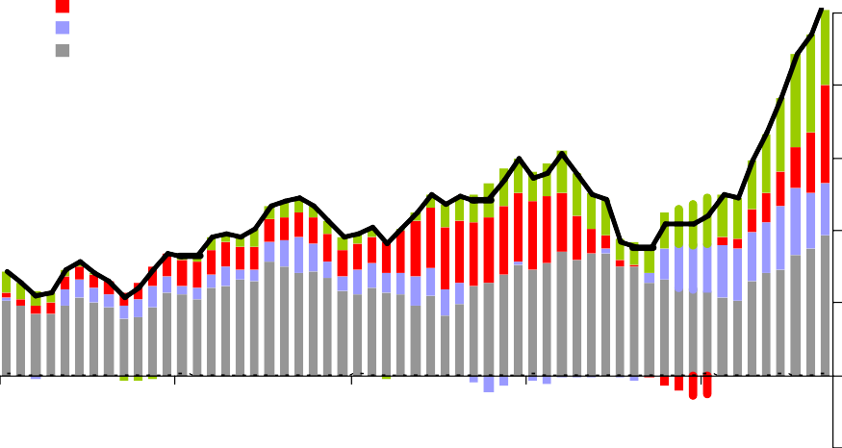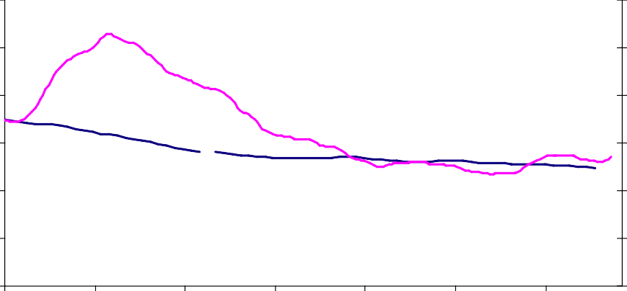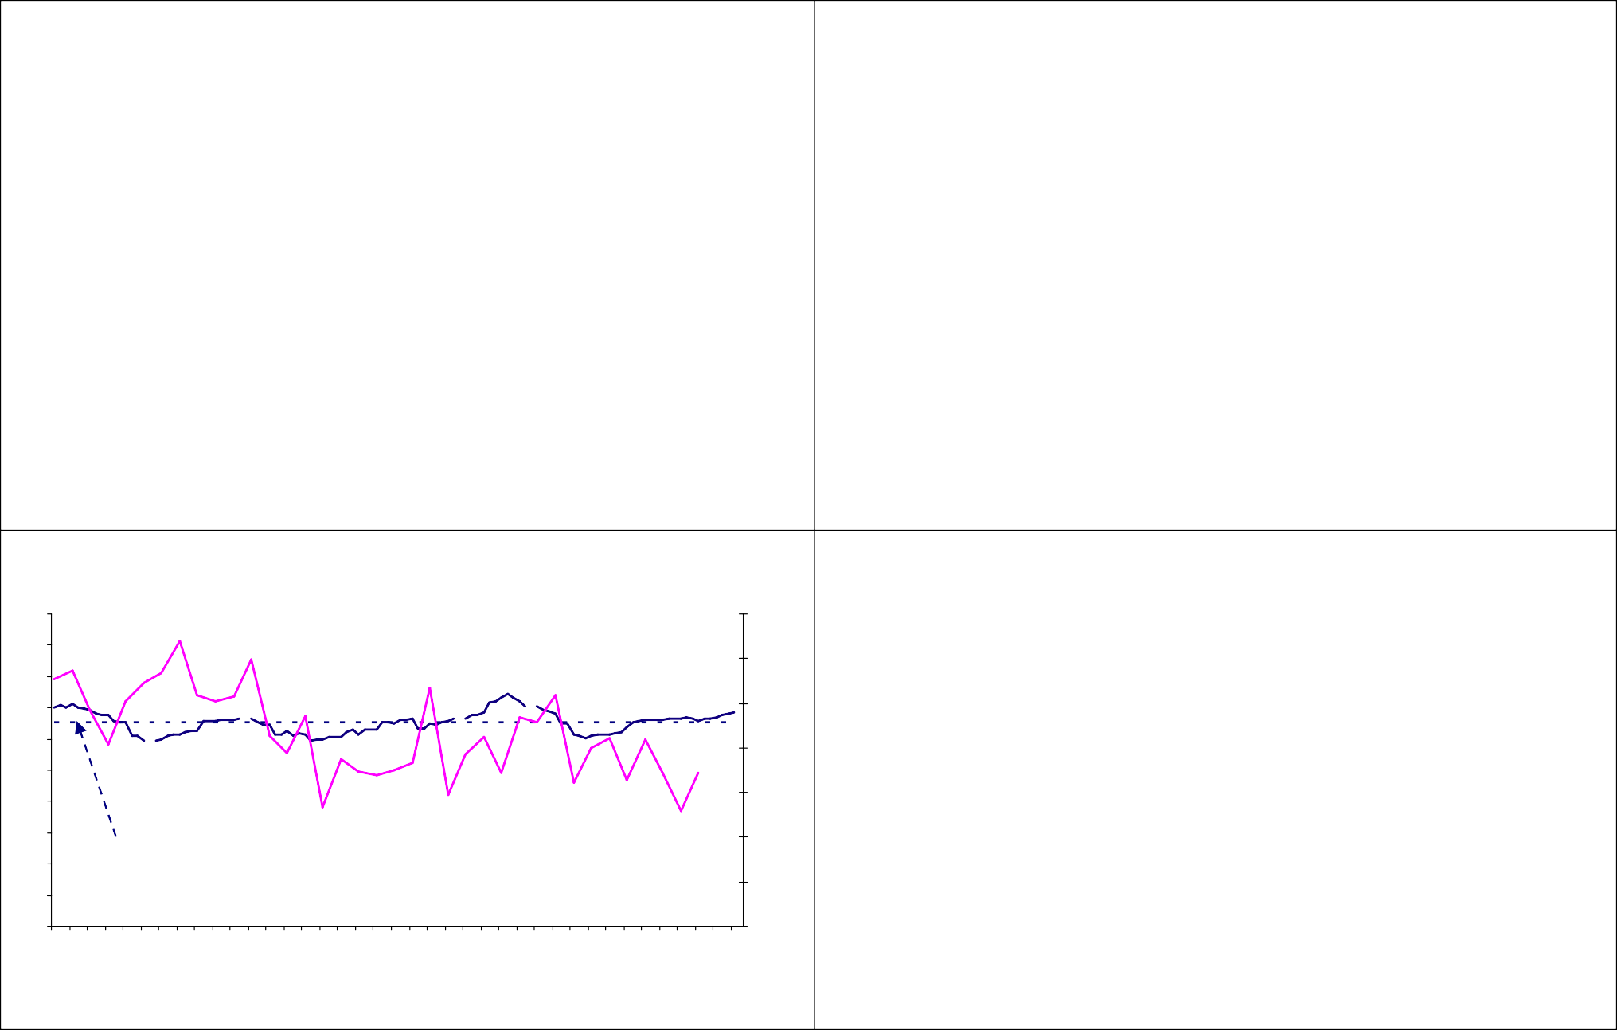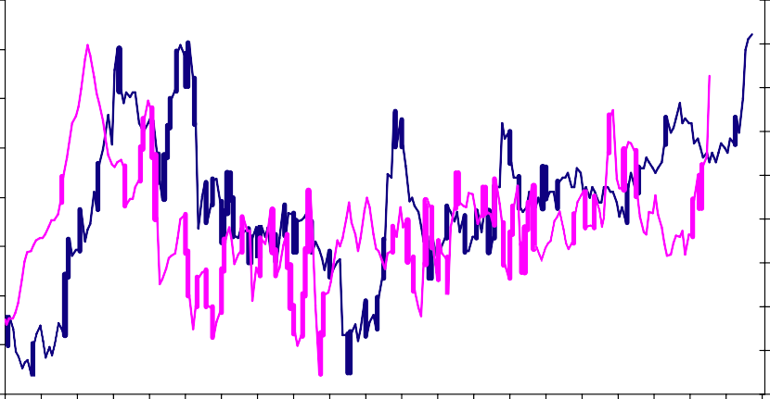

Food Utilities Petrol Other

**Per cent**

**5**

**4**

## Chart 2: Unionisation rate

Per cent

60 12

**Natural rate of unemployment* (RHS)**

50 10

40 8

**3**

30 6

**2**

20 **Unionisation rate (LHS)** 4

**1**

10 2

**0**

0 0

**2004 2005 2006 2007 2008**

Source: ONS and Bank calculations

## Chart 3: UK earnings growth

Jan-90 Sep-92 Jun-95 Mar-98 Dec-00 Sep-03 Jun-06

**-1** Source: BERR and ONS

*Rolling average of the current data, and the next and past two months data.

## Chart 4: Fear of unemployment

Annual % grow th rate

5.0

4.5

4.0

Annual % grow th rate

60

Survey balance

7.0

**AEI: Whole economy wage settlements (LHS)**

50

6.0

40

**Fear of unemployment (as measured in a survey taken 12 months previously) (LHS)**

Thousands

250

200

150

3.5

3.0

2.5

2.0

1.5

5.0

30

4.0

20

3.0

10

2.0

100

50

0

-50

1.0

0.5

0.0

Mar-99 Jun-99 Sep-99 Dec-99 Mar-00 Jun-00 Sep-00 Dec-00 Mar-01 Jun-01 Sep-01 Dec-01 Mar-02 Jun-02 Sep-02 Dec-02 Mar-03 Jun-03 Sep-03 Dec-03 Mar-04 Jun-04 Sep-04 Dec-04 Mar-05 Jun-05 Sep-05 Dec-05 Mar-06 Jun-06 Sep-06 Dec-06 Mar-07 Jun-07 Sep-07 Dec-07 Mar-08 Jun-08 Sep-08

**AEI: 10-year whole economy mean (LHS)**

**LFS hourly pay (in main job only) (RHS)**

1.0

0.0

0

-10

-20

Jan-89

Jan-90

Jan-91

Jan-92

Jan-93

Jan-94

Jan-95

Jan-96

Jan-97

Jan-98

**Change in unemployment on previous three months (RHS)**

Jan-99

Jan-00

Jan-01

Jan-02

Jan-03

Jan-04

Jan-05

Jan-06

Jan-07

Jan-08

Jan-09

-100

-150

-200

Jan-10

Source: Bank of England, LFS, IDS, IRS, LRD Source: GfK, LFS

## Chart 5: Inflation expectations and perceptions

**Per cent**

## Chart 6: General public inflation expectations

Per cent

**60**

**50**

Perceptions = Expectations **40**

**30**

**20**

Perceptions > Expectations **10**

**0**

**2001 2002 2003 2004 2005 2006 2007 2008**

5.0

4.5

4.0

3.5

3.0

2.5

2.0

1.5

1.0

0.5

0.0

Nov-05 Jan-06 Mar-06 May-06 Jul-06 Sep-06 Nov-06 Jan-07 Mar-07 May-07 Jul-07 Sep-07 Nov-07 Jan-08 Mar-08 May-08 Jul-08 Sep-08

Nov-08

**Citi / YouGov median inflation expectations for 5-10 years' ahead**

**Citi / YouGov median inflation expectations for the 12 months’ ahead**

**Bank of England / NOP median inflation expectations for the 12 months’ ahead**

Source: Bank of England / NOP

## Chart 7: GDP growth

% change on year ago

30

25

**Nominal GDP growth**

Source: YouGov, Citi, NOP and Bank of England

## Chart 8: Oil prices

£ per barrel

70

**Real oil price (spot Brent)**

60

20 50

15 40

10

30

5

20

0

**Real GDP growth** 10

-5

Mar-56 Mar-58 Mar-60 Mar-62 Mar-64 Mar-66 Mar-68 Mar-70 Mar-72 Mar-74 Mar-76 Mar-78 Mar-80 Mar-82 Mar-84 Mar-86 Mar-88 Mar-90 Mar-92 Mar-94 Mar-96 Mar-98 Mar-00 Mar-02 Mar-04 Mar-06

Mar-08

0

1970

1972

1974

1976

1978

1980

1982

1984

1986

1988

1990

1992

1994

1996

1998

2000

2002

2004

2006

2008

**Nominal oil price (spot Brent)**

Source: ONS

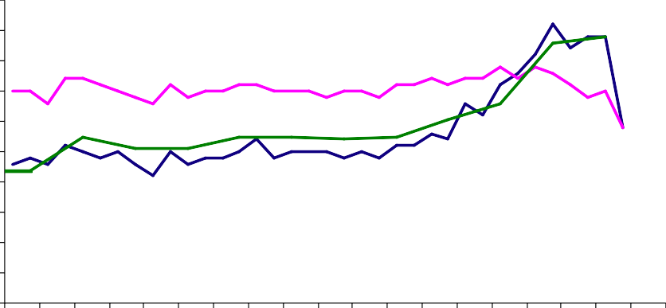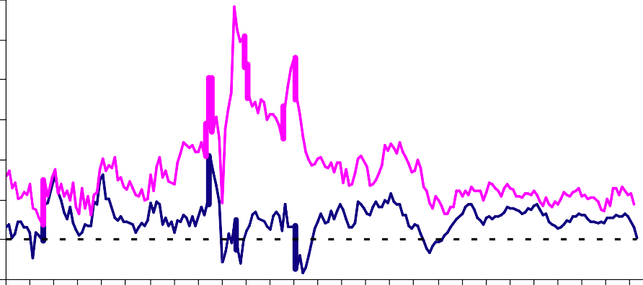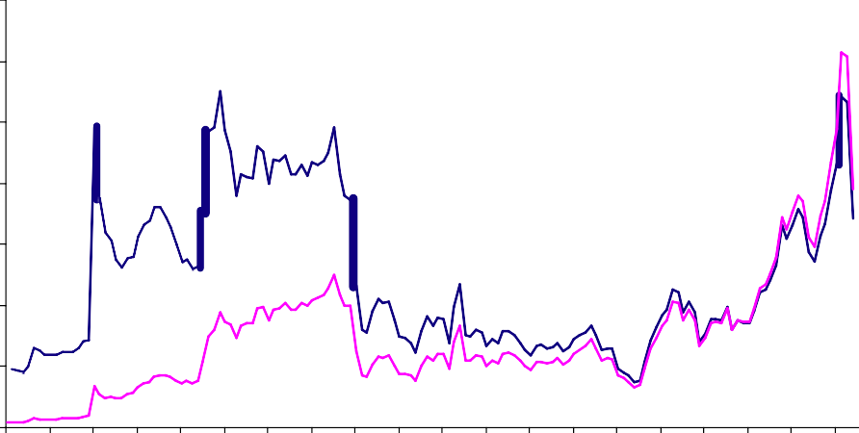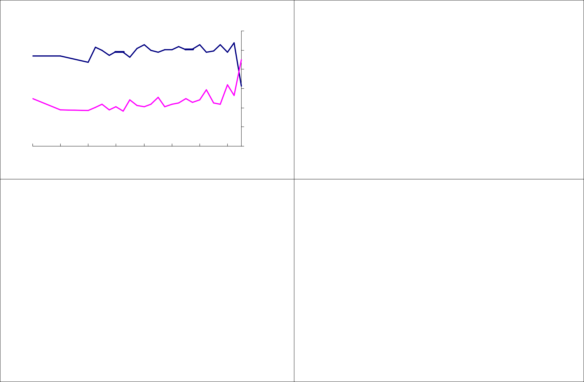

Source: Bank calculations

## Chart 9: Libor Spread

Basis points 200

## Chart 10: Financial accelerator

180

160

140

**Spread between three-month £ inter-bank rate and Bank Rate**

# Capital

120

100

80

60

40

20

0

06-Aug-07

20-Aug-07

03-Sep-07

17-Sep-07

01-Oct-07

15-Oct-07

29-Oct-07

12-Nov-07

26-Nov-07

10-Dec-07

24-Dec-07

07-Jan-08

21-Jan-08

04-Feb-08

18-Feb-08

03-Mar-08

17-Mar-08

31-Mar-08

14-Apr-08

28-Apr-08

12-May-08

26-May-08

09-Jun-08

23-Jun-08

07-Jul-08

21-Jul-08

04-Aug-08

18-Aug-08

01-Sep-08

15-Sep-08

29-Sep-08

13-Oct-08

27-Oct-08

# Funding

**Credit conditions**

# Collateral

Source: Bank of England, British Bankers Association

## Chart 11: Banks’ funding gap

**Chart 12: Banks’ external balance sheet – gross flows**

**6 month flows (£ blns)**

**Net funding from abroad**

**Funding raised through**

**500**

**400**

**300**

**increased foreign borrowing**

**Funding rais ed through sales of foreign assets**

**2000 2001 2002 2003 2004 2005 2006 2007**

**2008**

**200**

**100**

**0**

**-100**

**-200**

**-300**

**-400**

**-500**

Source: Bank of England Source: Bank of England. Q3 2008 based on two months’ actual data and projection for third month

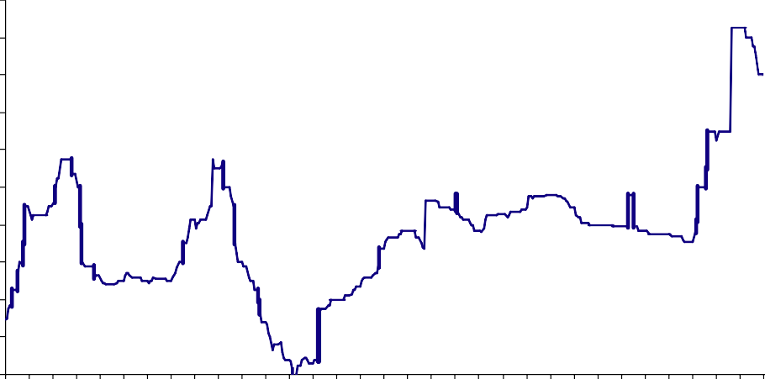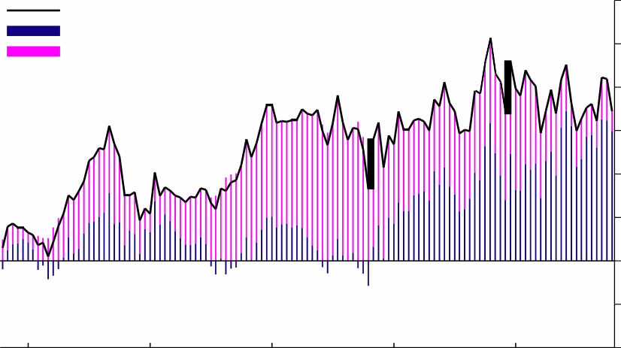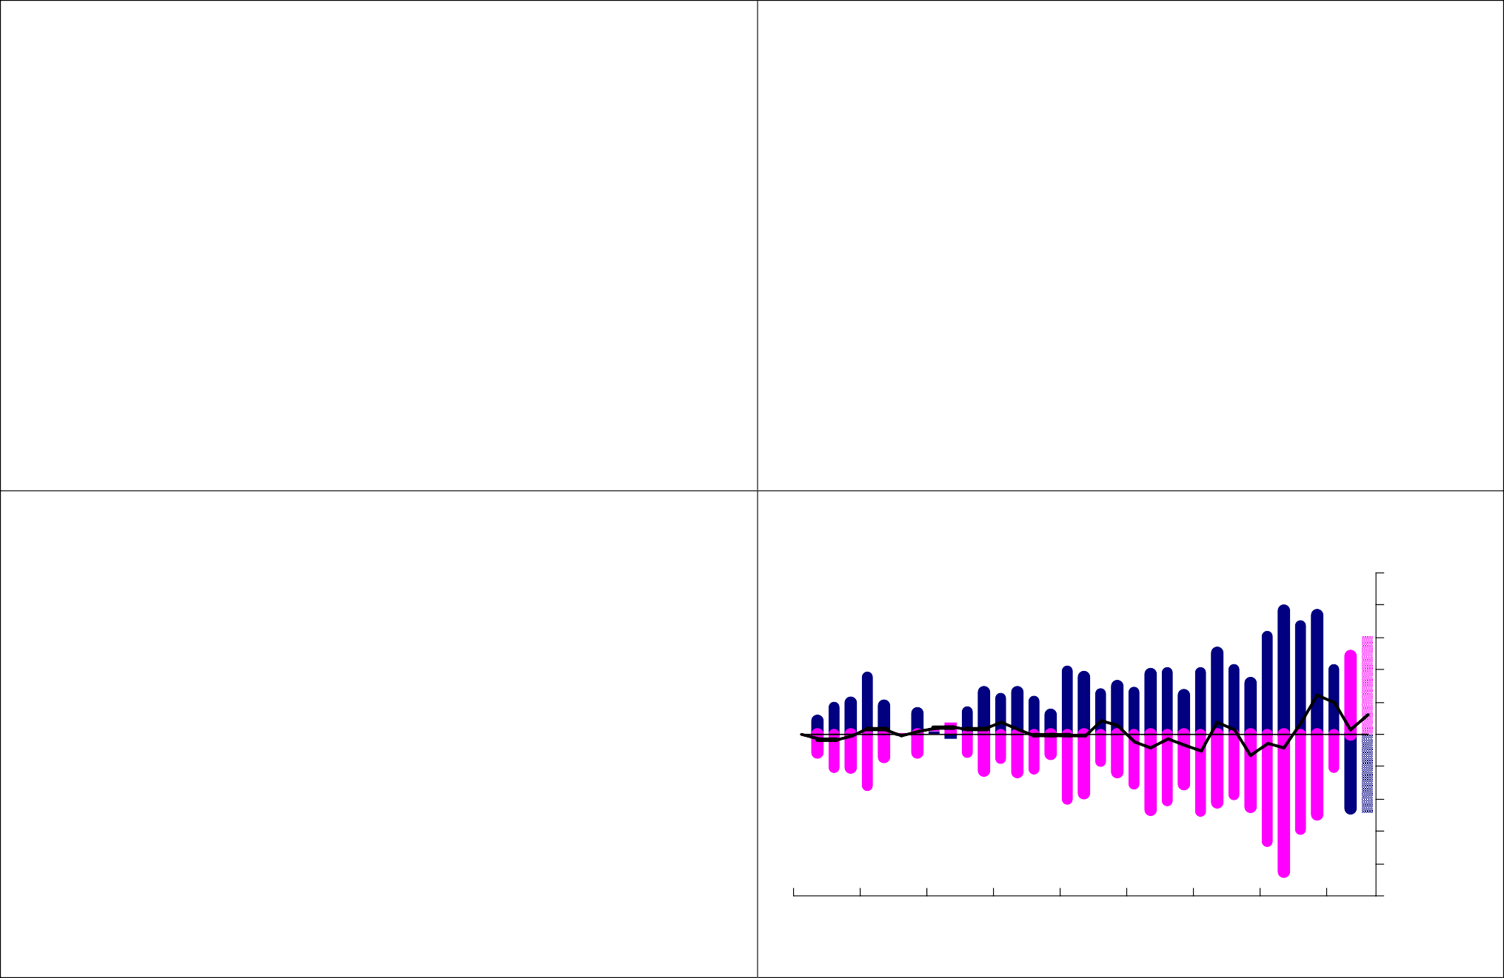

## Chart 13: Baltic Dry Index (1 May 1985 to 27 October 2008) Chart 14: Baltic Dry Index, recent daily falls

Index 12000

10000

8000

6000

4000

2000

**Long Run Average (May 1985 – August 2002)**

06 October 2008

Per cent 0%

-2%

-4%

-6%

-8%

-10%

-12%

The Index has fallen for the past 16 days

0

May-85 May-86 May-87 May-88 May-89 May-90 May-91 May-92 May-93 May-94 May-95 May-96 May-97 May-98 May-99 May-00 May-01 May-02 May-03 May-04 May-05 May-06 May-07 May-08 May-09

07 October 2008

08 October 2008

09 October 2008

10 October 2008

13 October 2008

14 October 2008

15 October 2008

16 October 2008

17 October 2008

20 October 2008

21 October 2008

22 October 2008

23 October 2008

24 October 2008

27 October 2008

Source: Thomson Datastream

## Chart 15: UK equities and house prices

% change oya

% change oya

Source: Thomson Datastream

## Chart 16: Consumer confidence and demand for staff

Balance

Balance

70

50

30

10

-10

-30

**Halifax house price index**

**FTSE 100 Index**

70

50

30

10

-10

-30

20

10

0

-10

-20

70

**GfK Headline Balance of UK Consumer Confidence (LHS)**

65

60

55

50

45

-50

-70

May-98

Nov-98

May-99

Nov-99

May-00

Source: Halifax, FTSE

**UK's biggest 5 banks' equity prices\***

-50

-70

May-02

May-03

May-04

May-05

May-07

May-08

Nov-08

-30

-40

-50

Oct-97

Apr-98

40

**REC Demand for Permanent Staff (RHS)** 35

30

Oct-98 Apr-99 Oct-99 Apr-00 Oct-00 Apr-01 Oct-01 Apr-02 Oct-02 Apr-03 Oct-03 Apr-04 Oct-04 Apr-05 Oct-05 Apr-06 Oct-06 Apr-07 Oct-07 Apr-08

Oct-08

*Banks are: Barclays, HBOS, HSBC, Lloyds TSB and RBS. Calculated as unweighted sum of all five banks' equity prices.

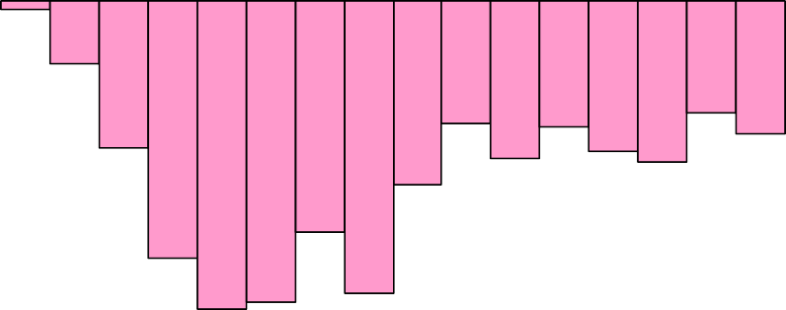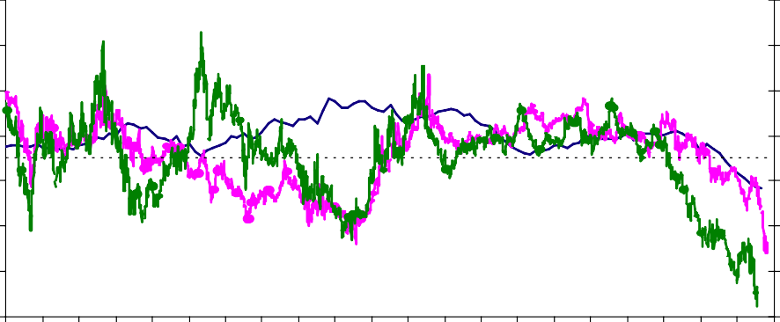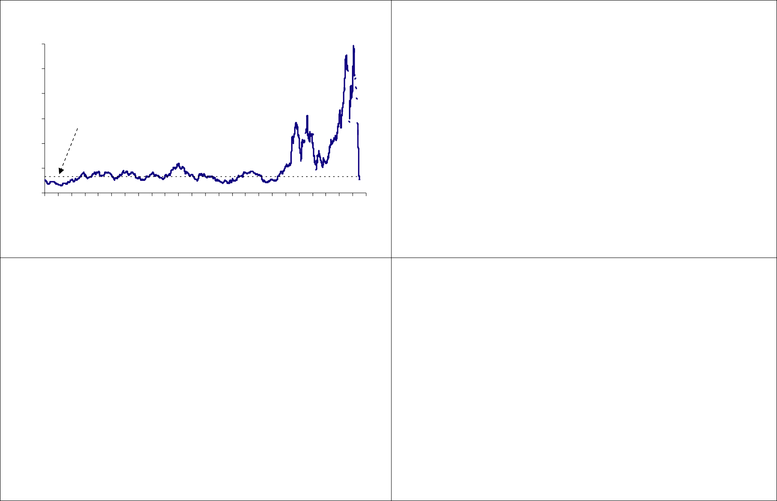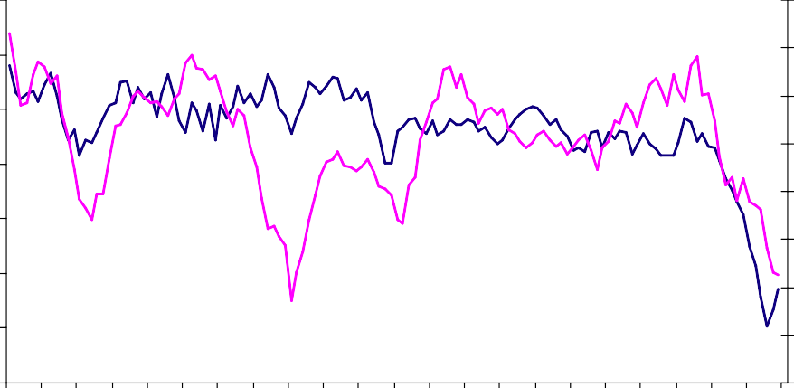

Nov-00

May-01

Nov-01

Nov-02

Nov-03

Nov-04

Nov-05

May-06

Nov-06

Nov-07

Source: GfK, REC

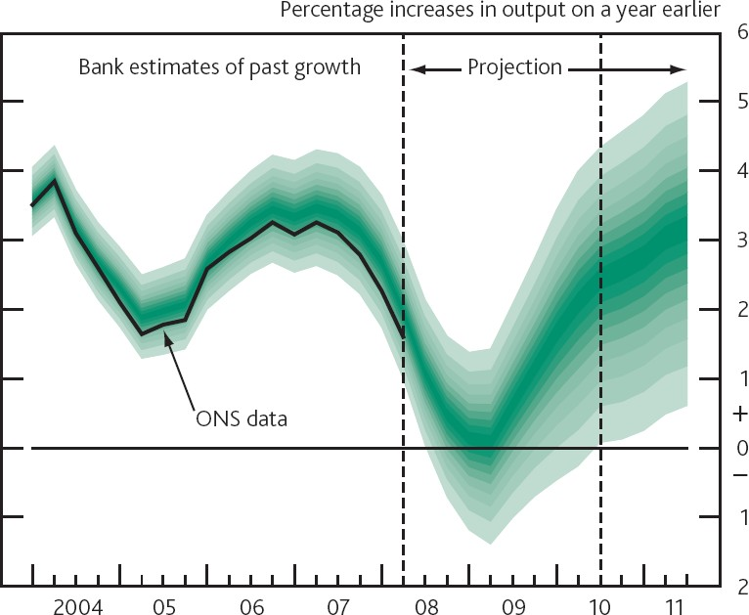

**Chart 18: August Bank of England *Inflation Report* GDP Projection (based on market interest rate expectations)**

Source: CIPS/Markit

35

40

Jul-97 Jan-98 Jul-98 Jan-99 Jul-99 Jan-00 Jul-00 Jan-01 Jul-01 Jan-02 Jul-02 Jan-03 Jul-03 Jan-04 Jul-04 Jan-05 Jul-05 Jan-06 Jul-06 Jan-07 Jul-07 Jan-08

Jul-08



**CIPS survey of manufacturing output**

**Chart 17: CIPS survey**

Index, 50 = no change

65

**CIPS survey of services activity**

60

55

50

45